Design and Analysis of Algorithms (24CSI104)

Introduction
Iteration and recursion are two fundamental programming techniques used to solve problems that require repetition. Both approaches achieve the goal of executing a set of instructions multiple times until a certain condition is met, but the method by which repetition is implemented differs significantly. In the study of Design and Analysis of Algorithms, understanding the nuances of iteration and recursion is crucial because they directly influence an algorithm’s performance, memory usage, clarity, and maintainability. While iteration relies on loops to perform repeated tasks, recursion relies on a function calling itself, often breaking the problem into smaller, manageable subproblems.

Iteration
Iteration is a method in which a set of instructions is executed repeatedly using loops such as for, while, or do-while. The repetition continues as long as a specified condition remains true, and once the condition becomes false, the loop terminates, and control passes to the next statement in the program. Iteration is widely used in programming due to its simplicity, efficiency, and low memory consumption.

Example :
A real-world example of iteration is counting the number of students present in a classroom. The teacher starts from the first student and counts each one sequentially until the last student is reached. This repeated counting process mirrors the working of an iterative loop, where the process continues until all items have been processed.

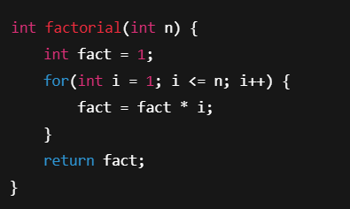

Iteration is commonly applied in searching for an element in an array, sorting algorithms like bubble sort and selection sort, processing files sequentially, handling sensor data, and in real-time systems where efficiency and low memory usage are essential.

Advantages :
- Constant memory usage
- Faster execution
- No overhead of function calls
- Absence of risk for stack overflow

Disadvantage:
- Iteration can sometimes produce lengthy
- Less readable code
- Particularly when dealing with hierarchical problems
- It is less expressive for problems that naturally fit a recursive structure

Real-World Applications:
  - Processing large datasets
  - Handling network packets
  - Sensor monitoring systems
  - Embedded systems programming

Scenarios Where Iteration is Preferred
Iteration is preferred when:
- Memory usage must be minimized.
- Input size is very large.
- Real-time systems are involved.
- Performance is critical.

Example code :
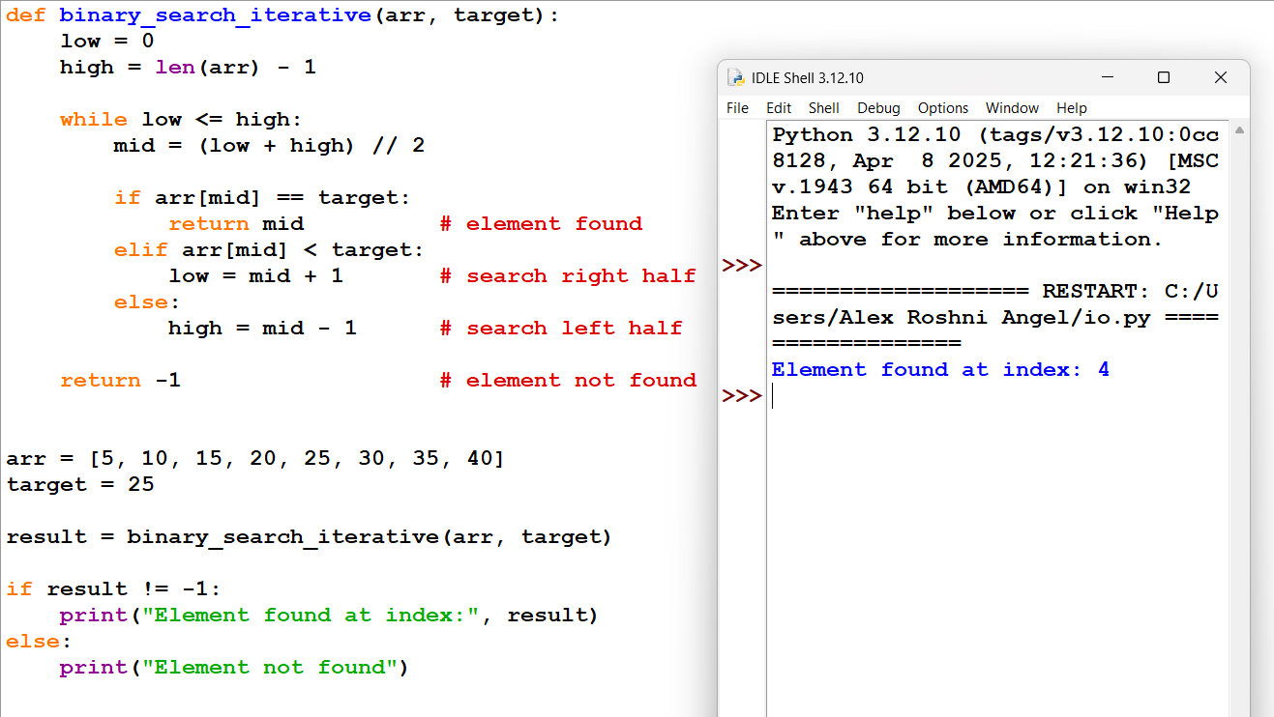
Code explanation:
In the iterative binary search, the program searches for the required element using a loop.
First, two variables low and high are set to the beginning and end of the array. The program then enters a while loop. Inside the loop, it finds the middle element of the array. If the middle element is equal to the target value, the search stops and the index is returned. If the target value is smaller than the middle element, the program continues searching in the left half of the array by updating high. If the target value is larger, the program searches in the right half by updating low. This process repeats until the element is found or the array is fully checked.

Recursion
Recursion is a programming technique in which a function solves a problem by calling itself with a smaller or simpler input until a base case is reached. Every recursive function requires two essential components: a base case that stops the recursion, and a recursive case that reduces the problem toward the base case. Recursion provides an elegant and natural way to represent problems that have hierarchical or nested structures, making it ideal for tasks that are difficult to implement iteratively.

Example:
A real-life analogy of recursion can be seen in the structure of a family tree. Each person may have children, who in turn may have their own children, and so on. To process the entire tree, one applies the same operation to each branch, which is conceptually similar to how recursive functions operate.

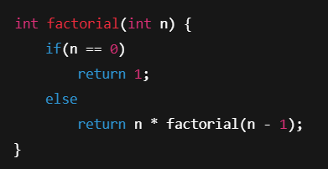

Recursion finds extensive application in algorithms such as binary search, merge sort, quick sort, depth-first search, tree traversals (preorder, inorder, postorder), and graph traversals. It is particularly useful in divide-and-conquer algorithms where a problem is naturally broken into smaller subproblems that can be solved independently.

Advantages :
- More readable code
- Simplifies complex problems
- Provides a natural representation of hierarchical or nested structures.

Disadvantages:
- Recursion is memory-intensive due to the function call stack
- Incurs additional overhead from repeated function calls
- It can lead to stack overflow if the recursion depth is too large

Real-World Applications:
- File system traversal
- Expression evaluation in compilers
- Artificial Intelligence search algorithms
- Graph traversal algorithms

Scenarios Where Recursion is More Appropriate
Recursion is more suitable when:
- The problem has a recursive mathematical definition.
- The problem can be divided into smaller identical subproblems.
- The data structure is hierarchical (trees, graphs).
- Divide-and-conquer strategy is used (Merge Sort, Quick Sort).

Example code :
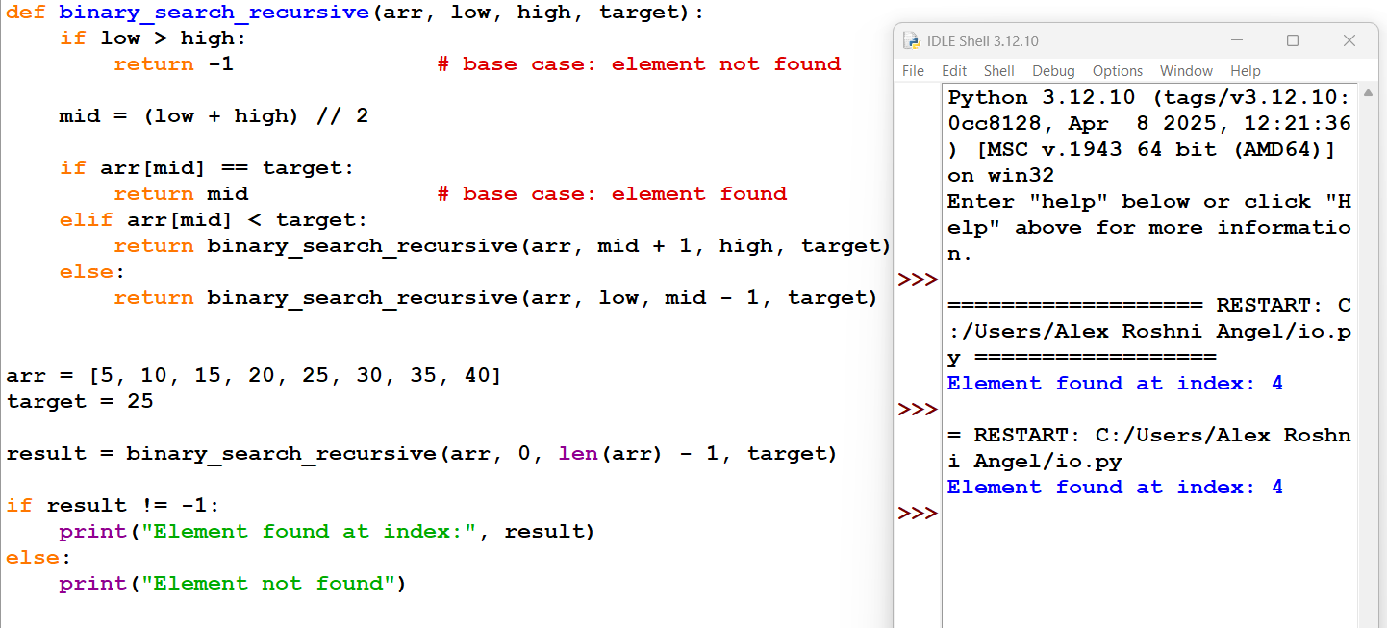

Code explanation:
In the recursive binary search, the program searches for the element by calling the same function again and again.
The function first checks the base case. If low becomes greater than high, it means the element is not present and the function stops. Otherwise, it calculates the middle element. If the middle element matches the target, the function returns the index. If the target is smaller than the middle element, the function calls itself to search in the left half of the array. If the target is larger, the function calls itself to search in the right half. Each function call reduces the search space until the element is found.

Comparison Between Iteration and Recursion
- Control Mechanism: Iteration uses loops, whereas recursion relies on function calls.
- Memory Usage: Iteration uses constant memory, while recursion consumes memory on the call stack.
- Speed: Iteration is faster due to lack of function call overhead; recursion is slower.
- Readability: Iterative code can become complex, whereas recursive code is often more readable and elegant.
- Risk: Iteration can lead to infinite loops if the condition is incorrect; recursion can lead to stack overflow if base cases are missing or input is too large.
- Applicability: Iteration is better for linear problems, real-time processing, and large data inputs. Recursion is better suited for hierarchical or divide-and-conquer problems like tree and graph processing.

Time Complexity Analysis
Time complexity refers to the amount of time an algorithm takes to run as input size increases.
Iterative Factorial:
- The loop runs n times.
Time Complexity = O(n)
Recursive Factorial:
- The function makes n recursive calls.
Time Complexity = O(n)

Space Complexity Analysis
Space complexity measures memory usage.
Iteration:
- Uses constant memory for variables.
Space Complexity = O(1)
Recursion:
- Uses stack memory for each recursive call.
Space Complexity = O(n)

Suitable Example Problems Solved by Both Methods
- Example 1: Factorial
Can be solved using both iteration and recursion.
- Example 2: Fibonacci Series
Both methods possible, but iterative approach is more efficient.
- Example 3: Binary Search
Better implemented using recursion for clarity.
- Example 4: Tree Traversal
Naturally implemented using recursion.

Conclusion
Both iteration and recursion are fundamental to algorithm design. Iteration is preferred when performance, speed, and memory efficiency are important. Recursion is preferred when clarity, problem decomposition, and elegance of code are prioritized. A proficient algorithm designer must understand both methods thoroughly and select the most appropriate approach based on the problem requirements. By understanding the advantages and disadvantages of each technique, programmers can design algorithms that are both efficient and maintainable.

